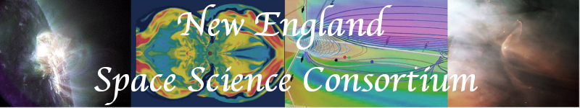

Summary of Meeting 7 :

Relationship between particle acceleration and magnetic reconnection

Sept. 12, 2006

The topic for discussion will be in the spirit of the generalization of fundamental processes in space plasma physics, in this case focused on the relationship between particle acceleration and magnetic reconnection.

The general topic of particle acceleration was taken up previously at the NESSC meeting at UNH. Some of the big questions that typically arise concern the interplay between stochastic acceleration versus shock acceleration. Both processes appear to go on and are, in fact, quite synergistic. Stochastic processes are thought to be responsible for the acceleration of suprathermal ions, while shocks appear to accelerate particles to the highest energies. It is interesting, however, that in quasar jets the accelerated particles are thought to be extremely rich in high-energy electrons. It also appears that many of the transient (or impulsive) solar events, thought to be associated with reconnection, are electron rich.

This opens an important connection between solar and magnetospheric energetic phenomena concerning the He3 enrichment problem. In both regimes, the enrichment of He3 is explained as the result of stochastic acceleration. However, there is an unquantified relationship between the stochastic acceleration and reconnection. Presumably, the reconnection triggers the release and subsequent dissipation of Poynting flux. Direct methods of acceleration involving parallel electric fields are also invoked to explain transient events, but the relationship between direct (or DC) electric fields and stochastic acceleration is unclear.

The topic is interesting, in part, because it touches on a broad array of sub-fields in both space physics and astrophysics. We opened discussion with a series of questions to:

- Are direct acceleration methods viable?
- How is stochastic acceleration and reconnection related?
- Why are impulsive events electron-rich?
- How can we utilize analogs between magnetospheric and solar/astrophysical reconnection to develop our understanding of the phenomenon?
- How can we utilize laboratory measurements to understand the phenomenon?
- What remote or in situ measurements are lacking?
- Are we asking the right questions?

We had a number of contributions, summarized briefly below

Jim Drake’s Magnetic Island Hypothesis

Jim drake proposes a first-order Fermi acceleration process where electrons gain energy while being trapped in magnetic holes in the reconnection region. Our discussion raised questions about whether the magnetic holes will exist in full 3-D kinetic simulations, and how much total energy the electrons can acquire through the acceleration process.

Dietmar Krauss-Varban’s Ion Bem hypotheis

Dietmar proposes a very different process in which initially the ions are heated near the reconnection region, and subsequently form ion beams. These beams, in turn, provide free-energy for fast magnetosonic waves that are readily transit-time damped to accelerate the electrons. Thus, ion beams provide the free energy for electron heating and tail formation [Krauss-Varban & Welsch, 2006].

The Axford Conjecture and Association between CMEs and plamoids in the magnetosphere

The association between CMEs and plamsoids in the magnetotail has been noted in a pevious meeting. Discussion at this meeting focused on the physical boundary conditions that lead to a CME release and their association with plasmoids. Interestingly, it was noted that the energy partition between plasmsheet heating and the magnetic energy carried away by plasmoids has not been studied. Can this be likened to heating/flare acceleration and magnetic energy release in CME eruption? It was agreed that a subgroup of the NESSC will consider putting together a paper that addresses these physical links (generalization of the Axford conjection) between reconnection at the Sun and in the magnetosphere. George Siscoe will be leading the group, which included Steve Kahler, Jeff Hughes, Ed DeLuca, Janet Luhmann, Harlan Spence, Justin Kasper, Mary Hudson, and myself (among others). If you are interested in contributing to this, or I mistakenly left you off the list, please contact me.

Justin Kasper discussed type-3 radio bursts and provided some interesting correlations between burst length and speed suggesting a that the speed of electron propagation could be inferred from the observations. Such radio observations may provide an interesting method of characterizing the heights and character of reconnection in the corona.

